Data Mining - Mining World Wide Web
The World Wide Web contains huge amounts of information that provides a rich source for data mining.

Challenges in Web Mining
The web poses great challenges for resource and knowledge discovery based on the following observations −
- The web is too huge − The size of the web is very huge and rapidly increasing. This seems that the web is too huge for data warehousing and data mining.
- Complexity of Web pages − The web pages do not have unifying structure. They are very complex as compared to traditional text document. There are huge amount of documents in digital library of web. These libraries are not arranged according to any particular sorted order.
- Web is dynamic information source − The information on the web is rapidly updated. The data such as news, stock markets, weather, sports, shopping, etc., are regularly updated.
- Diversity of user communities − The user community on the web is rapidly expanding. These users have different backgrounds, interests, and usage purposes. There are more than 100 million workstations that are connected to the Internet and still rapidly increasing.
- Relevancy of Information − It is considered that a particular person is generally interested in only small portion of the web, while the rest of the portion of the web contains the information that is not relevant to the user and may swamp desired results.

Mining Web page layout structure
The basic structure of the web page is based on the Document Object Model (DOM). The DOM structure refers to a tree like structure where the HTML tag in the page corresponds to a node in the DOM tree. We can segment the web page by using predefined tags in HTML. The HTML syntax is flexible therefore, the web pages does not follow the W3C specifications. Not following the specifications of W3C may cause error in DOM tree structure.
The DOM structure was initially introduced for presentation in the browser and not for description of semantic structure of the web page. The DOM structure cannot correctly identify the semantic relationship between the different parts of a web page.

Vision-based page segmentation (VIPS)
- The purpose of VIPS is to extract the semantic structure of a web page based on its visual presentation.
- Such a semantic structure corresponds to a tree structure. In this tree each node corresponds to a block.
- A value is assigned to each node. This value is called the Degree of Coherence. This value is assigned to indicate the coherent content in the block based on visual perception.
- The VIPS algorithm first extracts all the suitable blocks from the HTML DOM tree. After that it finds the separators between these blocks.
- The separators refer to the horizontal or vertical lines in a web page that visually cross with no blocks.
- The semantics of the web page is constructed on the basis of these blocks.
The following figure shows the procedure of VIPS algorithm −
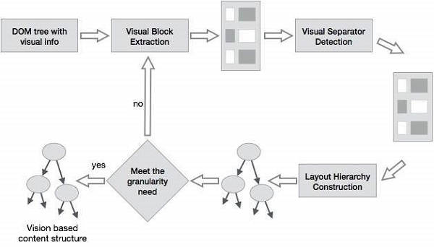

Data Mining - Mining Text Data
Text databases consist of huge collection of documents. They collect these information from several sources such as news articles, books, digital libraries, e-mail messages, web pages, etc. Due to increase in the amount of information, the text databases are growing rapidly. In many of the text databases, the data is semi-structured.
For example, a document may contain a few structured fields, such as title, author, publishing_date, etc. But along with the structure data, the document also contains unstructured text components, such as abstract and contents. Without knowing what could be in the documents, it is difficult to formulate effective queries for analyzing and extracting useful information from the data. Users require tools to compare the documents and rank their importance and relevance. Therefore, text mining has become popular and an essential theme in data mining.

Information Retrieval
Information retrieval deals with the retrieval of information from a large number of text-based documents. Some of the database systems are not usually present in information retrieval systems because both handle different kinds of data. Examples of information retrieval system include −
- Online Library catalogue system
- Online Document Management Systems
- Web Search Systems etc.
Note − The main problem in an information retrieval system is to locate relevant documents in a document collection based on a user's query. This kind of user's query consists of some keywords describing an information need.
In such search problems, the user takes an initiative to pull relevant information out from a collection. This is appropriate when the user has ad-hoc information need, i.e., a short-term need. But if the user has a long-term information need, then the retrieval system can also take an initiative to push any newly arrived information item to the user.
This kind of access to information is called Information Filtering. And the corresponding systems are known as Filtering Systems or Recommender Systems.

Basic Measures for Text Retrieval
We need to check the accuracy of a system when it retrieves a number of documents on the basis of user's input. Let the set of documents relevant to a query be denoted as {Relevant} and the set of retrieved document as {Retrieved}. The set of documents that are relevant and retrieved can be denoted as {Relevant} ∩ {Retrieved}. This can be shown in the form of a Venn diagram as follows −
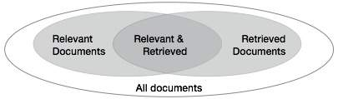
There are three fundamental measures for assessing the quality of text retrieval −
- Precision
- Recall
- F-score

Precision
Precision is the percentage of retrieved documents that are in fact relevant to the query. Precision can be defined as −
Precision= |{Relevant} ∩ {Retrieved}| / |{Retrieved}|

Recall
Recall is the percentage of documents that are relevant to the query and were in fact retrieved. Recall is defined as −
Recall = |{Relevant} ∩ {Retrieved}| / |{Relevant}|

F-score
F-score is the commonly used trade-off. The information retrieval system often needs to trade-off for precision or vice versa. F-score is defined as harmonic mean of recall or precision as follows –
F-score =
recall x precision / (recall + precision) / 2

